SEMINAR-1
Theme: Methods of measurement.

Measurement method is a method or a set of techniques for comparing a measured quantity with its unit or scale in accordance with the implemented measurement principle.

About the general methods of obtaining measurement results , the methods are distinguished by:
A direct measurement method is a measurement in which the desired value of a quantity is found directly from experimental data. Direct measurements do not require measurement methods and are carried out according to the operational documentation for the measuring instrument used;

An indirect measurement method is a measurement, the result of which is determined on the basis of direct measurements of quantities associated with the measured quantity by a known dependence. Indirect measurements are used in cases where direct measurements cannot be performed, for example, when determining the density of a solid body calculated from the results of volume and mass measurements.

According to the measurement conditions:
Contact measurement method – based on the fact that the sensor element of the device is brought into contact with the object of measurement (body temperature measurement by a thermometer);

Non–contact measurement method is based on the fact that the sensitive element of the device is not brought into contact with the object of measurement (measuring the distance to the object by radar, measuring the temperature in the blast furnace by a pyrometer).

Based on the method of comparing the measured value with its unit, there are:
The method of direct evaluation is a method in which the value of the value is determined directly by the reading device of the SI indicator (thermometer, voltmeter, etc.). The measure reflecting the unit of measurement does not participate in the measurement. Its role is played in SI by a scale graded during its production with the help of sufficiently accurate SI.

The method of comparison with the measure is a method in which the measured value is compared with the value reproduced by the measure (measurement of mass on lever scales with balancing weights). There are three varieties of this method:
The null method is a method of comparison with a measure in which the resulting effect of the quantities on the comparison device is brought to zero, for example, measurements of electrical resistance by a bridge with its complete balancing;

The substitution method is based on a comparison with a measure, in which the measured value is replaced by a known value reproduced by the measure, keeping all conditions unchanged, for example, weighing with alternating placement of the measured mass and weights on the same scale cup;

The differential method is a measurement method in which the measured quantity is compared with a homogeneous quantity having a known value slightly different from the value of the measured quantity, and in which the difference between these two quantities is measured.

Depending on the measuring instruments used in the measurement process, there are:

Instrumental method;
-an expert method based on the use of data from several specialists (for example, in qualimetry, sports, art, medicine);

Heuristic methods that are based on intuition. The method of pairwise comparison is widely used, when the measured values are compared with each other in pairs, and then ranking is performed based on the results of this comparison;

Organoleptic assessment methods based on the use of human sensory organs (touch, smell, sight, hearing, taste). For example, the assessment of surface roughness by the sample visually or by touch.
Methods of measurement with an examples :
The group of comparison methods with the measure includes the following methods: substitution, differential, null and coincidences.

- substitution measurement method; substitution method is a method of comparison with a measure in which the measured quantity is replaced by a measure with a known value of the quantity.

An example is Weighing with alternating placement of the measured mass and weights on the same cup of scales (the Board method).

- differential measurement method - a measurement method in which the measured value is compared with a homogeneous value having a known value slightly different from the value of the measured value, at which the difference between these two values is measured.

Example — Measurements performed when checking length measures by comparison with a reference measure on a comparator

- zero method (measurement) - a method of comparison with a measure in which the resulting effect of the measured quantity and measure on the comparison tool is brought to zero.

An example is the measurement of electrical resistance by a bridge with its complete balancing.

- the method of measurements by addition; the method of addition is a method of comparison with a measure in which the value of the measured value is supplemented by a measure of the same value in such a way that their sum equal to a predetermined value affects the comparison device.

References:
- Not known, Главный форум метрологов “Methods of measurement” https://info.metrologu.ru/spravochnik/metrologiya/izmereniya/izmereniya_15.html
- 2022, Saurabh Vaidya. “Methods of measurement” https://instrumentationtools.com/methods-of-measurement/

SEMINAR-2
Theme: Classification of measuring instruments.
Static and dynamic characteristics

GOST 8.009-84 establishes the nomenclature of the normalized characteristics of measuring instruments, which, regardless of the type of measured quantities and the principles of operation of measuring instruments, are necessary for a reasonable assessment of the measurement error carried out under specific conditions in both static and dynamic modes, as well as methods of normalization and forms of their presentation.

The metrological characteristic of SI is a characteristic of one of the properties of measurements that affect the measurement result or its error.

Normalized metrological characteristics are metrological characteristics established by regulatory and technical documents.

The actual metrological characteristics are the SI characteristics obtained experimentally.

The standard establishes methods of standardization and presentation forms for each characteristic, and provides recommendations for the selection of complexes of metrological characteristics.

The main metrological characteristics are: accuracy (error), division price, scale measurement range, scale reading range, SI sensitivity threshold, variation, etc.

The accuracy of the SI is estimated by the margin of error, and this is the largest value of the SI error established by the normative and technical documentation for this type of SI, at which it is still considered suitable for use.

The price of dividing the scale is the difference in the values of the values corresponding to two adjacent marks of the scale.

The division of the scale is the distance between the midpoints of two adjacent strokes.

Some metrological characteristics are determined from static characteristics.

The range of readings is the range of values of the scale, limited by its final and initial values.

The measurement range (the working part of the scale) is the range of values of the measured value (on the scale of the device), for which the permissible SI errors are normalized.

In particular cases, when the static characteristic is either rectilinear or proportional, the range of readings coincides with the measurement range.

The sensitivity of the SI is the ability of the SI to respond to a change in the input signal and is estimated by the ratio of the change in the output signal to the change in the input signal that caused it.

Variation is a characteristic of the constancy of the SI readings or the output signal of the measuring transducer. The variation manifests itself in the ambiguity of the course of the static characteristic of the device or converter with an increase and decrease in the measured value.

The performance characteristics of an instrument are mainly divided into two
categories:

i) Static characteristics

ii) Dynamic characteristics

Static characteristics:

The set of criteria defined for the instruments, which are used to measure the
quantities which are slowly varying with time or mostly constant, i.e., do not vary
with time, is called ‘static characteristics’.

The various static characteristics are:

i) Accuracy

ii) Precision

iii) Sensitivity

iv) Linearity

v) Reproducibility

vi) Repeatability
The performance characteristics of an instrument are mainly divided into two
categories:

i) Static characteristics

ii) Dynamic characteristics

Static characteristics:

The set of criteria defined for the instruments, which are used to measure the
quantities which are slowly varying with time or mostly constant, i.e., do not vary
with time, is called ‘static characteristics’.

The various static characteristics are:

i) Accuracy

ii) Precision

iii) Sensitivity

iv) Linearity

v) Reproducibility

vi) Repeatability
The performance characteristics of an instrument are mainly divided into two categories:
i) Static characteristics
ii) Dynamic characteristics

Static characteristics:
The set of criteria defined for the instruments, which are used to measure the quantities which are slowly varying with time or mostly constant, i.e., do not vary with time, is called ‘static characteristics’.
The various static characteristics are:
i) Accuracy
ii) Precision
iii) Sensitivity
iv) Linearity
v) Reproducibility
vi) Repeatability
vii) Resolution
viii) Threshold
ix) Drift
x) Stability
xi) Tolerance
xii) Range or span
Dynamic characteristics:
The set of criteria defined for the instruments, which are changes rapidly with time, is called ‘dynamic characteristics’.
The various dynamic characteristics are:
i) Speed of response
ii) Measuring lag
iii) Fidelity
iv) Dynamic error

Speed of response:
It is defined as the rapidity with which a measurement system responds to changes in the measured quantity.

Measuring lag:
It is the retardation or delay in the response of a measurement system to changes in the measured quantity. The measuring lags are of two types:
a) Retardation type:
In this case the response of the measurement system begins immediately after the change in measured quantity has occurred.
b) Time delay lag:
In this case the response of the measurement system begins after a dead time after the application of the input. Fidelity: It is defined as the degree to which a measurement system indicates changes in the measurand quantity without dynamic error.

Dynamic error:
It is the difference between the true value of the quantity changing with time & the value indicated by the measurement system if no static error is assumed. It is also called measurement error.

References:
- https://lektsii.com/2-14838.html
- https://instrumentationapplication.com/static-characteristics-and-dynamic-characteristics-of-instruments/
- http://mediatoget.blogspot.in/2012/01/static-dynamic-characteristics- of.html

SEMINAR-3
Theme: Metrological aspects of chemical analysis

In practice, quality control of chemical analysis results is often quite difficult. This is due to the specifics of chemical analysis - a multi-stage indirect measurement procedure, which includes not only the measurement operation as such.

A separate task is to ensure the quality of the results of chemical analysis, achieving the necessary accuracy. Its solution requires a variety of measures, not only scientific, but also organizational. These measures, established by law, are developed and implemented by special sectoral, national and interstate services.

A special section of analytical chemistry - chemical metrology deals with the study of all issues related to the measurement of chemical quantities, methods and means of ensuring their unity, control and quality assurance of chemical analysis results. The basic rules and laws of chemical metrology are the same for all methods of analysis. Knowledge of chemical metrology, the ability to correctly process, evaluate and interpret the results of chemical analysis and, more broadly, any chemical experiment is one of the important components of the training of a chemical analyst.

Any method of chemical analysis has the task of extracting information about a substance using various measuring instruments. Thus, the analytical technique is a complex, multi-stage measurement procedure. It is at the stage of measurement (and subsequent processing and interpretation of the results) that the deep internal unity of the most diverse analytical methods is clearly manifested, and the regularities of measuring chemical quantities are of fundamental importance for all sections of analytical chemistry, constituting, in essence, its philosophical basis. A special section of analytical chemistry, called chemical metrology, deals with the study of general issues related to the measurement, processing and interpretation of chemical analysis results.

Metrology is the science that studies methods of measuring quantities. Measurement is understood as the definition of the numerical value of the measured quantity, expressed in certain units. During chemical analysis, metrological characteristics of substances are obtained and their compliance with certain standards and norms is determined [11].

Analytical chemistry conducts a metrological assessment of the substance and determines its compliance with the requirements of regulatory and technological documentation. In order for the results of quantitative analysis to be correct, all analytical instruments are regularly subjected to mandatory testing in special metrological laboratories. If necessary, adjust and calibrate the instruments and meters.

Tasks of analytical chemistry as a metrological science:

1) Calculation of the quantitative content of substances in materials, elements, functional groups in substances;

2) Determination and calculation of correctness and reproducibility of chemical analysis;

3) Assessment of the correctness of analytical instruments and meters and their calibration;

4) Development of metrological documents regulating qualitative and quantitative chemical parameters of substances and materials - state standards, technical specifications, pharmacopoeia articles;

5) Metrological assessment of the applicability of chemical reactions for purposes and analysis.

In general, the measurement consists in comparing the measured and the known value. For example, when weighing a substance on a scale, its mass is compared with the mass of weights. A known quantity must be expressed in certain units of measurement. For example, the mass is expressed in kilograms. Units of measurement can be basic (independent) and derived - derived from the basic.

To carry out chemical analysis, it is necessary to know the exact type of calibration function.
For some analysis methods, the exact type of the calibration function is known from theory. An example of such methods is gravimetry, in which the analytical signal is mass, and the calibration function is described by the equation. Its only parameter is the molar mass of the substance M, established with high accuracy. Such methods, which do not need experimental determination of the calibration function, are called absolute. However, there are very few absolute methods of chemical analysis.

The simplest and most common method of graduation is the method of external standards. It is also often referred to as the "ordinary" grading method or the "grading graph" method (the validity of the latter term, however, is questionable, since with other, special, grading methods, the grading function is also often represented graphically). In this method, a number of OS with the content of the component being determined c1, c2, ... cn are taken, all the analytical procedures necessary according to the methodology are carried out with them and their analytical signals are measured (y1, y2, ... yn, respectively). According to the obtained pairs of experimental values (ci, yi), the dependence of y on c is constructed and approximated by a suitable algebraic function or graphically (Fig. 1). At the same time, they usually try to choose such analysis conditions that this dependence would be linear. Then the unknown object is analyzed, its analytical signal yx is measured and using the obtained grading function is found (also algebraically or graphically) the corresponding value of cx. For example, in the case of a linear calibration function described by the equation y = kc + b, the unknown content can be found as

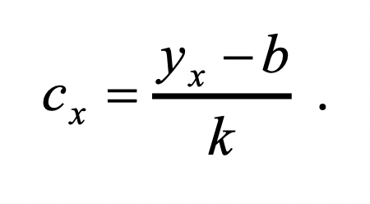

The value b, which is the value of the analytical signal at zero concentration of the component being determined, is called the background value of the signal. It plays an important role in assessing the detection limit of the technique.
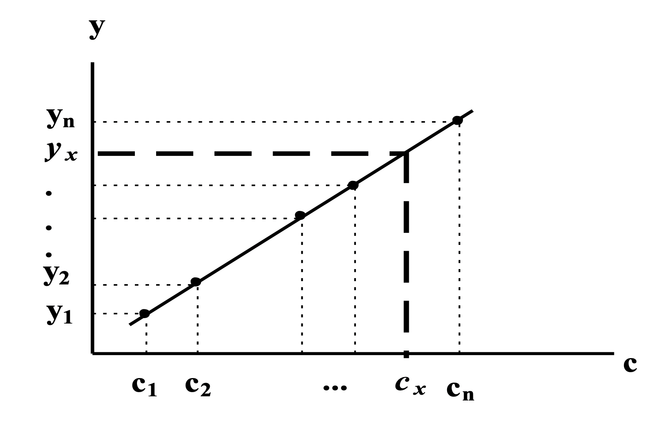
Fig. Grading and determination of content according to the method of external standards

Sometimes the method of external standards is further simplified by reducing the number of OS to two (the method of limiting solutions) or even one (the method of one standard). In the method of limiting solutions, the linear (in the selected concentration range) character of the calibration function is postulated in advance (and, if possible, experimentally checked), and the OS is chosen so that c1<cx<c2. It is easy to verify by performing the appropriate mathematical transformations that in this case
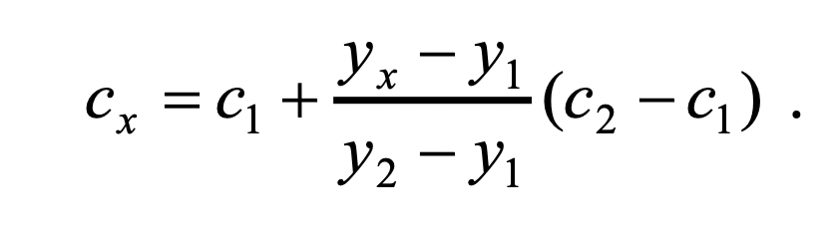

If c1 and c2 are close enough to cx, then the method of limiting solutions sometimes gives more accurate results than the "full" version of the method of external standards.
In the method of one standard, they assume not just a linear, but a directly proportional form of the calibration function y = kx (without its own term, there is no background signal). In this case
Sometimes the method of external standards is further simplified by reducing the number of OS to two (the method of limiting solutions) or even one (the method of one standard). In the method of limiting solutions, the linear (in the selected concentration range) character of the calibration function is postulated in advance (and, if possible, experimentally checked), and the OS is chosen so that c1<cx<c2. It is easy to verify by performing the appropriate mathematical transformations that in this case
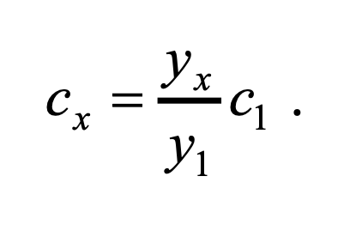
In any variant, the method of external EU standards is prepared and applied separately from the analyzed sample (hence the name). Therefore, the composition and properties of the OS do not always correspond exactly enough to those for the analyzed sample. In some cases, this can lead to significant errors in the results. In such situations, special calibration methods should be used.

References:
- http://www.chem.msu.su/rus/teaching/analyt/garmasch.pdf
- https://inis.iaea.org/collection/NCLCollectionStore/_Public/33/008/33008973.pdf
- https://otherreferats.allbest.ru/chemistry/00367600_0.html

